**Biochemistry 1**

**The Atom**

**An atom is made up of three subatomic particles: protons, neutrons, and electrons.**

* **Protons** have a positive charge (+),
* **Electrons** have a negative charge (–),
* **Neutrons** have no charge (neutral).

In a neutral atom, the number of protons equals the number of electrons, so the positive and negative charges cancel each other out, resulting in no overall charge.

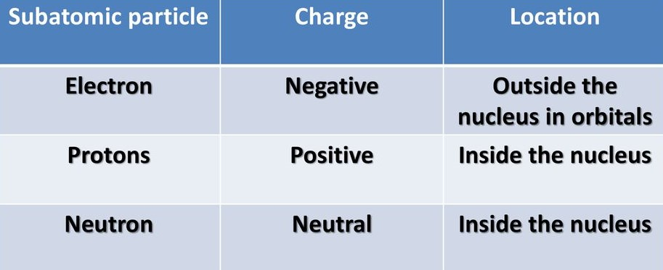

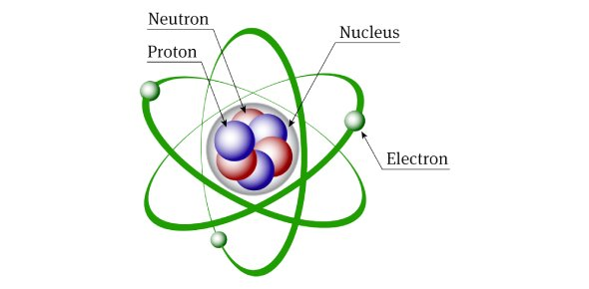

*Electrons in the ground state occupy the lowest available energy level, where they are most stable. When they absorb energy, they can move to a higher level, known as the excited state.*

**DR SALMA KHALED BIOLOGY EDUCATOR**

**Isotopes**

*Isotopes are atoms of the same element with the same number of protons but different numbers of neutrons.*

*Carbon-12 and carbon-14 are isotopes of carbon.  
They both have 6 protons and 6 electrons, but carbon-12 has 6 neutrons, while carbon-14 has 8 neutrons*

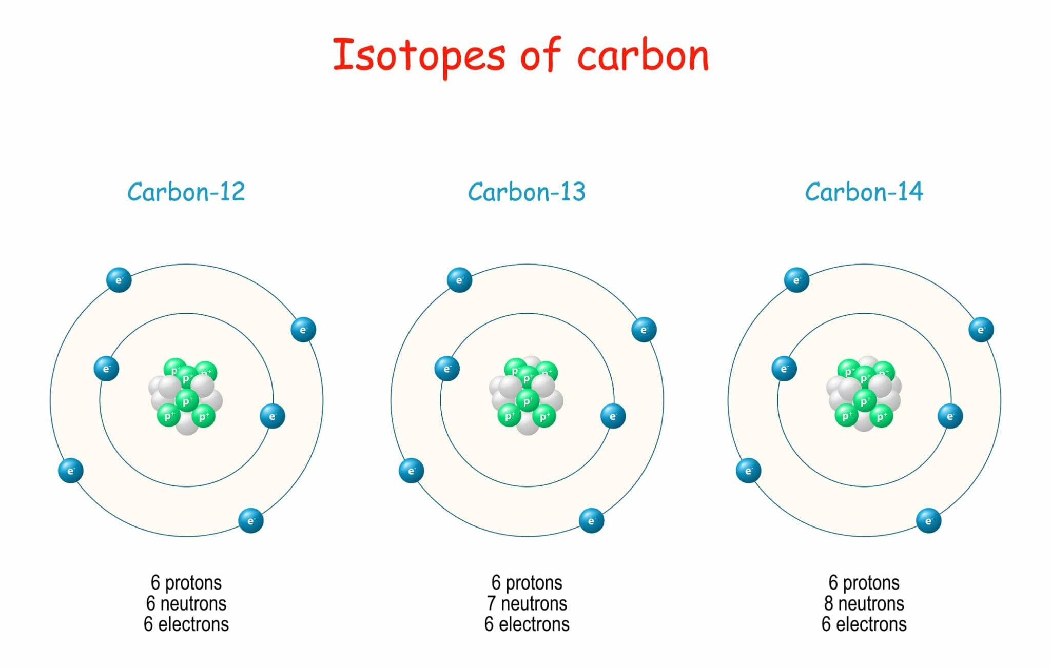

*Some isotopes, such as carbon-14, are radioactive and are called radioisotopes.  
Their nuclei break down over time and release particles. This process happens at a predictable rate, known as the half-life.  
Scientists use this to estimate the age of things like the Earth, which is about 4.6 billion years old.*

**Bonding**

**Atoms bond to become stable by filling their outer electron shells.**

* **Covalent bonds** form when atoms **share electrons**, creating a **molecule**.
* **Ionic bonds** form when electrons are **transferred** from one atom to another.
  + An atom that **gains electrons** becomes a **negative ion** (anion).
  + An atom that **loses electrons** becomes a **positive ion** (cation).

**DR SALMA KHALED BIOLOGY EDUCATOR**

**Intermolecular attractions:**

**Hydrogen Bonding**

• It keeps **the two strands of DNA** together by linking the **bases**, forming a **double helix**.

• It also makes **water molecules stick together**, which helps with things like **sweat and evaporation.**

**Non-Polar Molecules**

• Only the weakest attractions, called **van der Waals forces**, exist between **nonpolar molecules**.

**Characteristics of Water**

**Water is asymmetrical and highly polar. It forms strong hydrogen bonds, which cause:**

1. **High specific heat** → helps keep temperatures stable
2. **High heat of vaporization** → sweating cools the body
3. **Cohesion** (water + water) → insects can walk on water, water rises in tall trees
4. **Adhesion** (water + other surfaces) → helps water move from roots to leaves
5. **Ice is less dense and takes up more space** → ice floats on water

**PH**

• **pH** measures how acidic or basic a solution is.  
• **pH < 7** → acidic, **pH > 7** → basic (alkaline), **pH = 7** → neutral  
• As **H⁺ (hydrogen ion)** concentration increases, **pH goes down**.

**DR SALMA KHALED BIOLOGY EDUCATOR**

• A solution with **pH 1** is **10× more acidic** than pH 2, and **100× more acidic** than pH 3, and so on.  
➔ As **hydroxide ions (OH⁻)** increase, **pH increases** (more basic).

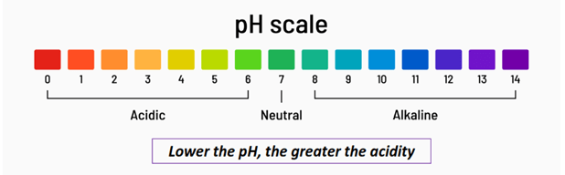

• **pH of human blood** = 7.4  
• **pH of small intestine** = 8  
• **pH of stomach** = 2 to 3 (very acidic)  
• **pH of bile** = 11 (very basic)

**Buffer:**  
Biological systems use **buffers** to keep pH stable.  
The most important buffer in human blood is the **bicarbonate ion (HCO₃⁻)**.

**Acid rain:**  
Caused by air pollutants like **SO₂, SO₄, and CO₂**.  
It has a pH **less than 5.6** and can damage the environment.

**DR SALMA KHALED BIOLOGY EDUCATOR**

**QUESTIONS**

**1) A solution with a ph of 3 is …. Times more acidic than one with a ph of 6**

A. 2

B. 3

C. 10

D. 100

E. 1,000

**2) What’s the difference between carbon 12 and carbon 14?**

A) Carbon 12 have 2 fewer electrons than carbon 14.

B) Carbon 12 have 2 fewer neutrons than carbon 14.

C) Carbon 12 have 2 more electrons than carbon 14.

D) Carbon 12 have 2 more neutrons than carbon 14.

**3) Which bond share electrons?**

A) Ionic bond

B) Covalent bond

**4) Which of the following is correct?**

A) Neutron has a positive charge and is inside the nucleus.

B) Neutron has a negative charge and is outside the nucleus.

C) Neutron has a positive charge and is outside the nucleus.

D) Neutron has no charge and is inside the nucleus.

**5) Which is not true about the characteristics of water ?**

A. It has heat of vaporization and high adhesion properties

B. It has adhesion properties and strong cohesion tension

C. It has a high specific heat and exhibits strong cohesion tension

D. It is a universal solvent and has law adhesion property

**DR SALMA KHALED BIOLOGY EDUCATOR**

**6)** **Which of the following is correct?**

A) Electron has a positive charge and is inside the nucleus.

B) Electron has a negative charge and is outside the nucleus.

C) Electron has a positive charge and is outside the nucleus.

D) Electron has a negative shared and is inside the nucleus.

**7) Which of the following is a type of bond in which electrons are shared ?**

A. Covalent

B. Hydrogen

C. Ionic

D. Electrostatic

**8) How does carbon -12 (mass number 12, atomic number 6 ) compare to**

**carbon-14?**

A. Carbon-12 has 8 more protons

B. Carbon-12 has 8 more neutrons

C. Carbon-12 has 2 fewer protons

D. Carbon-12 has 2 fewer neutrons

**9) Which is NOT a characteristic of water?**

A. Water has a high specific heat.

B. Water has a high heat of vaporization.

C. Water exhibits strong cohesion tension.

D. Water is less dense than ice.

E. Water is known as a universal solvent.

**10) The attraction between water molecules is an example of which of the**

**following?**

A. Adhesion

B. Cohesion

C. Evaporation

D. Transpiration

**DR SALMA KHALED BIOLOGY EDUCATOR**

**11) The pH of blood in humans?**

A. is lowest at birth and gradually increases with age up to a maximum level

B. is different for men and women

C. varies with the activity level of the individual

D. is highest at birth and gradually decreases to a minimum level

E. is normally 7.4 and resists change at all times

**CHALLENGING QUESTIONS**

**This table shows the pH of 8 substances.**

| **Substance** | **PH** |
| --- | --- |
| Battery Acid | 1.0 |
| Lemon Juice | 2.0 |
| Vinegar | 3.0 |
| Rain | 5.5 |
| Milk | 6.5 |
| Sea Water | 8.5 |
| Ammonia | 12.0 |
| Lye | 13.0 |
|  |  |

**Which of the following statement accurately compare rain to another**

**substance in the table?**

A. Rain has a higher hydroxide ion concentration than ammonia

B. Rain has a higher hydroxide ion concentration than milk

C. Rain has a lower hydroxide ion concentration than vinegar

D. Rain has a lower hydroxide ion concentration than lye

**DR SALMA KHALED BIOLOGY EDUCATOR**

**13) Isotopes differ from each other only in**

A. the number of electrons

B. the number of protons

C. the number of neutrons

D. how they react chemically

E. the size of the atom

**Questions 14-16**

**Match the description to the property of water.**

(A) Water exhibits strong cohesion tension.

(B) Water has a high heat of vaporization.

(C) Water has a high specific heat.

(D) Ice is less dense than water.

(E) Water is a universal solvent.

**14.** Water moves up tall trees because this is true.

**15.** Sweating is a cooling process because of this characteristic of water.

**16.** Fish can live through the winter in a lake that has ice floating on the

surface.

**17) A solution with a pH of 2 is a_____ times more acidic than one with**

A. 3

B. 10

C. 100

D. 1,000 E. 10,000

**18) All of the following are correct about water EXCEPT**

A. water is a molecule

B. there is little attraction between water molecules

C. the covalent bonds between oxygen and hydrogen are polar or unbalanced

D. the reason that water and lipids do not mix is because water is a polar

molecule while lipids are nonpolar

E. water has a relatively high heat of vaporization because of strong intermolecular attractions

**DR SALMA KHALED BIOLOGY EDUCATOR**

**19)**

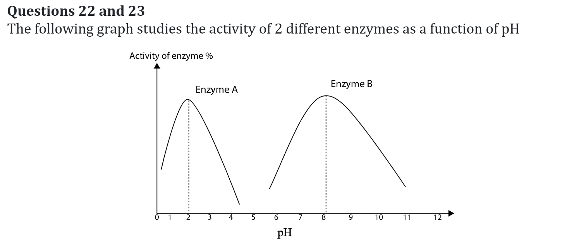

**22) From the above graph we can conclude that**

A) Enzyme A is found in the intestine and enzyme B is found in the stomach

B) Enzyme A is found in the mouth and enzyme B is found in the intestine

C) Enzyme A is found in the stomach and enzyme B is found in the intestine

D) Enzyme A is found in the stomach and enzyme B is found in the mouth

E) Both enzymes A and B are found in the stomach

**23) At pH 7,**

A) The amount of substrate obtained by enzymes A and B is 50 % and 0% respectively

B) The amount of substrate obtained by enzymes A and B is 10 % and 0% respectively

C) The amount of substrate obtained by enzymes A and B is 0 % and 50% respectively

D) The amount of substrate obtained by enzymes A and B is 0 %

E) The amount of substrate obtained by enzymes A and B is 100%

**DR SALMA KHALED BIOLOGY EDUCATOR**

**20)**

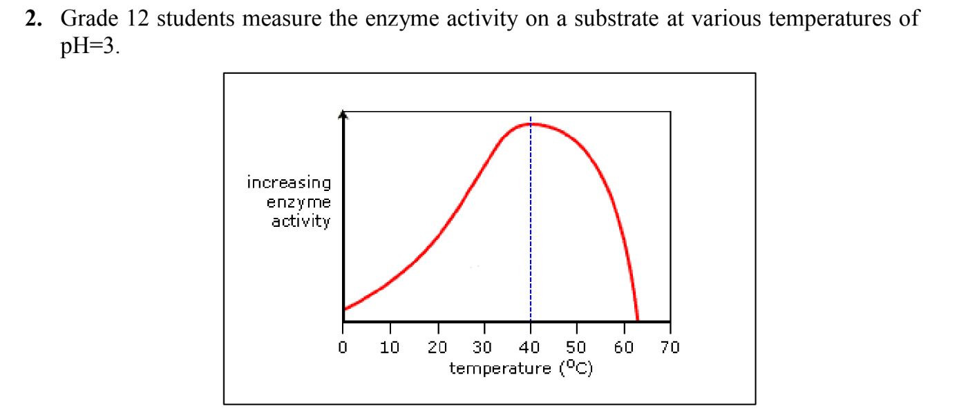

**Based on the data, what results can be predicted if the experiment is carried out at 62oC?**

A. No prediction would be valid.

B. An amount of product equal to that at 20oC would form.

C. An amount of product equal to that at the optimum temperature would form.

D. An amount of product equal to that at 5oC would form.

E. Little or no product would form.

**21)**